How can we clean up an oil spill?

Introduction: On April 20, 2010, a BP (British Petroleum) oil rig exploded in the Gulf of Mexico, killing 11 workers and beginning months of oil leaking unrestrained into the ocean. People began trying to control the spill with many different methods.
http://www.huffingtonpost.com/2010/04/30/louisiana-oil-spill-2010_n_558287.html#s172644&title=Gulf_Oil_Spill

Purpose:
The purpose of this lab is to simulate the clean-up of an oil spill. You will choose one type of absorbent material to see how much oil it can absorb. At the end of the lab, you will compare data with your classmates to see which material absorbs the most oil. You will practice using some common lab equipment, such as graduated cylinders, beakers, and a scale. Finally, you will compare our simulation to the real materials used to clean up the Gulf of Mexico oil spill of 2010.

Watch this CNN news clip about the 2010 oil spill in the Gulf of Mexico. Write down 3 important ideas that you heard in the clip here: NEED NEW Clip
http://www.youtube.com/watch?v=zZO0oNRTnFs

- ________________________________________________________________________________

- ________________________________________________________________________________

- ________________________________________________________________________________

Materials

Tray
Fork
Ruler
beaker
Graduated cylinder
Petri dish
Material of your choice (5 grams x four trials = 20 grams)
50 mL of vegetable oil

Optional absorbant materials (___________________ Variable)

Cotton
String
Feathers
Sawdust
Hair
Moss
Perlite
Diaper materials
Paper towel

Lab Safety
Stay in your seat as you conduct your lab/ raise your hand for permission to get up.
Do not pour ANY oil down the drain.
Use a petri dish on the scale to find the mass of your material before and after soaking in oil.

Procedure
- Gather your materials. Measure out 5 grams. (You will need four samples, so measure four groups, each with a mass of 5 grams)
- Fill one beaker with 50 ml of oil.
- Pour the oil on your tray.
- Put your material on the surface of the oil for 30 seconds.
- With a fork, remove your material and let the oil drip from it for 5 second only.
- Find the new mass of the materials + oil.
- Record this info in the data table under trial #1
- Repeat steps 4-7 three more times with the same material.

Diagram- Draw your lab procedure (one drawing per step!)

Data Table : You will be reporting your data in the form of a table. How many rows will you need? How many columns? Draw it below.

Data analysis
Calculate average values for your absorbant material, and make a bar graph including averages from ALL group’s absorbant materials.

Example: 25 mL oil +35mL oil + 20 mL oil + 22 mL oil
________________________________________ = ________ mL oil absorbed
4 trials

- Your material: ____________________

- Material: _______________________

- Material: _______________________

- Material: _______________________

- Material: _______________________

- Material: _______________________

Data Table- Averages: Record the data from above into the table below.

Absorbant Material | Average mL of oil absorbed
Your variable:

Bar Graph: Graph the data from the table above
Remember: What does every good graph need? What type of graph should you use? How will you space out your numbers (scale)?
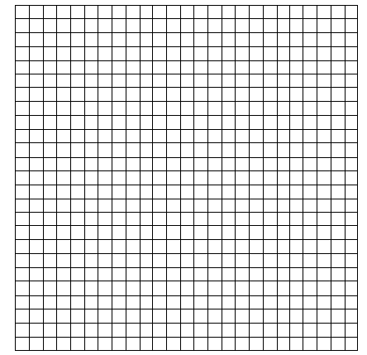

Discussion
In this lab I wanted to find out ___________________________________________________________
___________________________________________________________________________________________________________________.
Before I started the experiment, I thought _________________________________________________
___________________________________________________________________________________________________. After doing the experiment, I found that I was ______________________________ because _____________________________________________________________________________.
The results of my lab were that __________________________________________________________
__________________________________________________________________________________________________________________________________________________________________________The results mean that __________________________________________________________________________________________________________________________________________________________________________. Compared to other people who did the experiment, I found that ___________________________________________________________________________________________________________________________________________________________.
Although I was very careful when I did this experiment, I made an error when I _________________________________________________________________________________________________________________________________________________________________________ . The next time I do this experiment, I could improve it by __________________________________________________________________________________________________________________________________________________________________________

Conclusion
In this experiment I found that __________________________________________________________ _________________________________________________________________________________________________________________________________________________________________________________________. Overall, I learned that _________________________________________________
____________________________________________________________________________________________________________________________________________________________________________________________________________________________________________________________________________________________________________________________________________________.

